SRS for the project of Healhcare

The project is about to create a software on healthcare system in which there will be 3 pages under the patient registration module one for patient registration ,patient Search ,patient update and delete page.

Now you design the pages based on Bootstrap and validate them using javascript and jquery where you need to convert the module for each of the technology using javascript and jquery.

Use this test case for developing in angular 4 as well where the pages will be replaced by Angular 4

component and write the client side scripting using the typescript code.

For each of the button click event show a message on confirming process further.

Below is the image :--

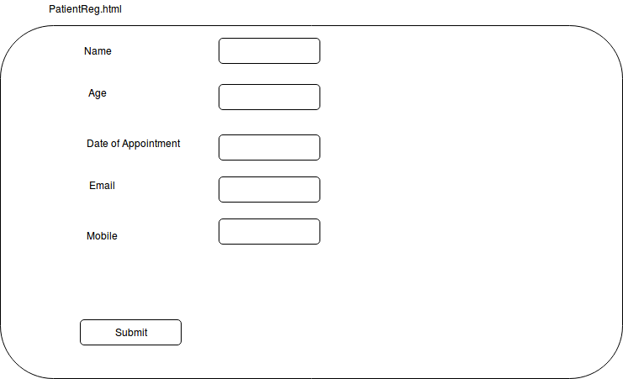

here use panel for sorrounding the html and bootstrap component .

Each of the pages there shulde be a menu bar for navigation purpose, having link for all the three pages and a link for home page that willl be the first page of the project.

The home page will have three link on the menu bar for the above 3 pages and a bootstrap carousal

on the body.

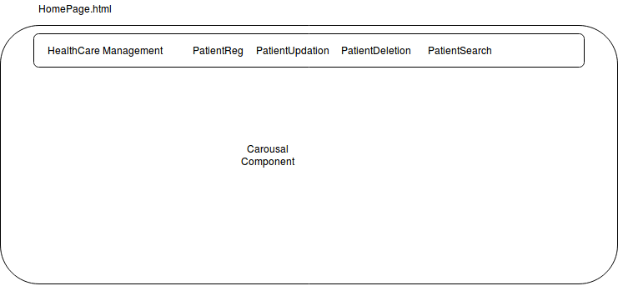

Patient Updation Page will be same page but when the patient updation link will be clicked

then the PatientReg.html page will be loaded on browser but now this page will have another

a label for showing ID and a text box for showing a value that can not be changed as it is the predefined ID of patient.(use dom manipulation of jquery) just below the name field.

Patient Search Page :--

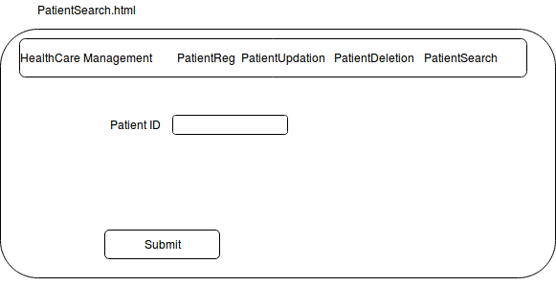

Patient Deletion Page :--

